
Company
Logotype

Cone Beam Computed Tomography- Report



Porur Dental X-rays & CBCT

Patient Name : Mr. Ravi | Date of Report : 01.07.2024
Age/ Gender : 44 years/ Male | Region of Interest : CBCT Maxilla
Referring doctor: Dr. B. Abinaya | Indication : Cyst?
Clinical Notes: Nil
PATIENT INFORMATION

CBCT- Maxilla provided
CBCT – IMAGE DETAILS

RADIOGRAPHIC INTERPRETATION

- In relation to 16, 17, 18 bone loss extending upto the apical third in 17, 18 and extending beyond the apical third in 16 is evident.
- The left maxillary sinus is present with mucosal thickening along the floor of the sinus and discontinuity in relation to its floor in 16 region.
- Dental caries: 14, 15.

RADIOGRAPHIC IMPRESSION

- Oro antral communication- right maxillary sinus.
- Chronic periodontitis: 16, 17, 18.
- Dental caries: 14, 15.

Kindly correlate with clinical findings


IMAGES FOR REFERENCE

RECONSTRUCTED PANORAMIC VIEW

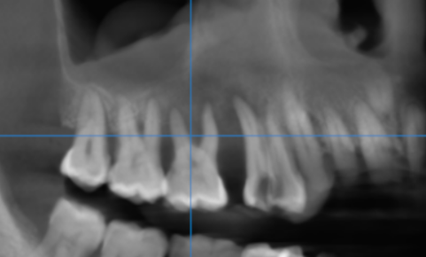

3-DIMENSIONAL VIEW
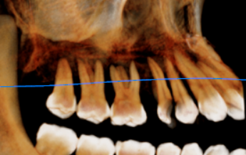

CROSS SECTIONAL VIEW

16 region | 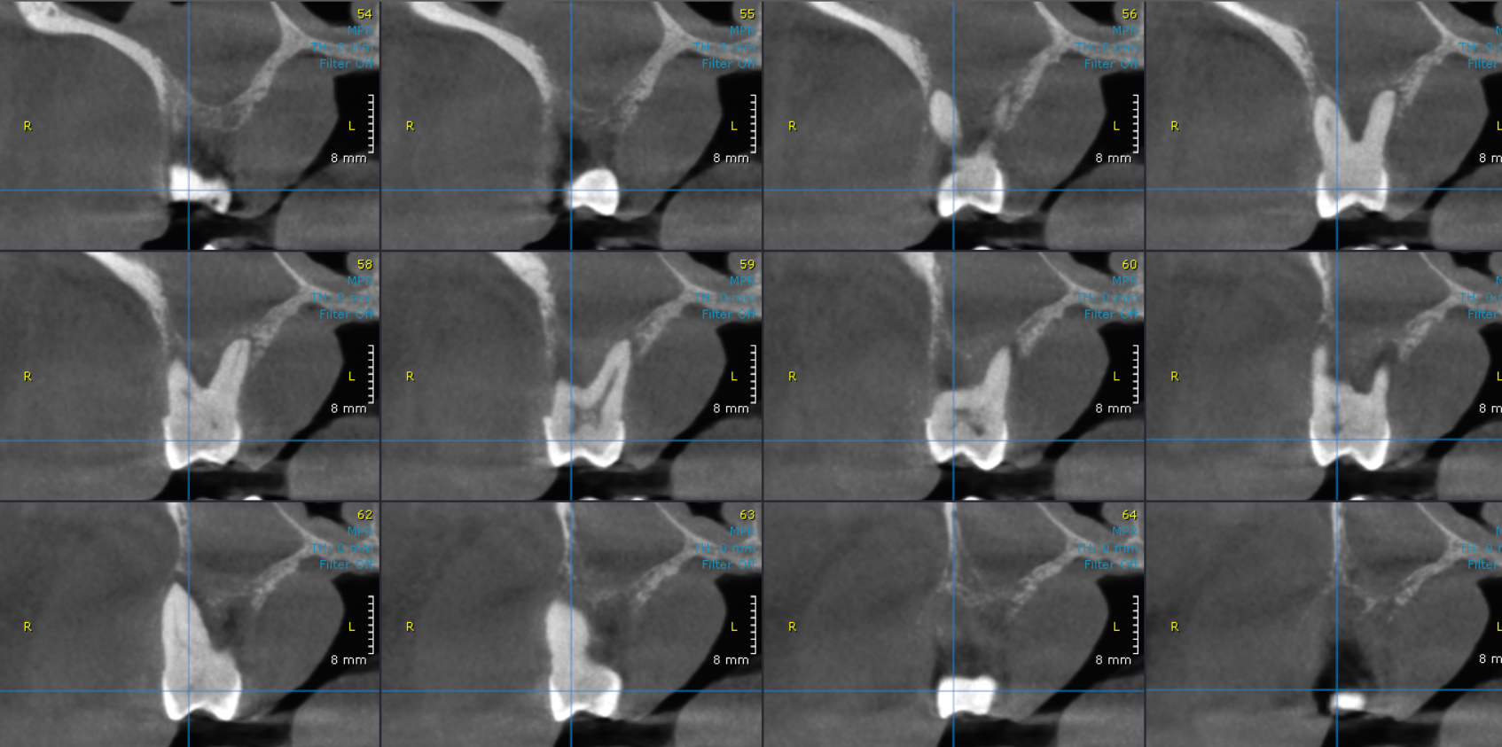
17 region | 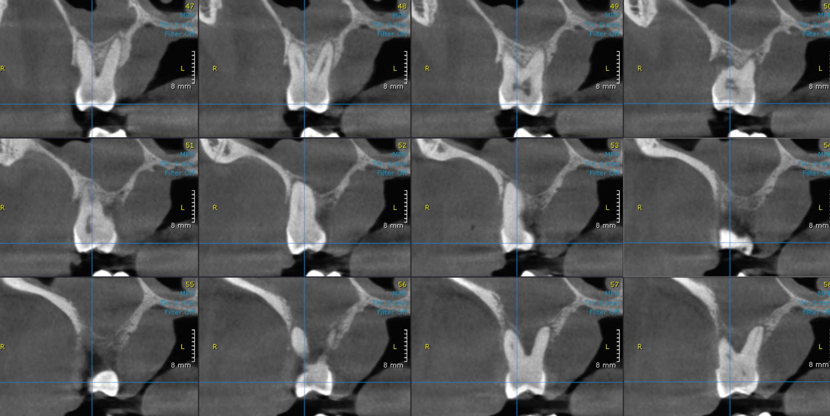

**** End of report ****

